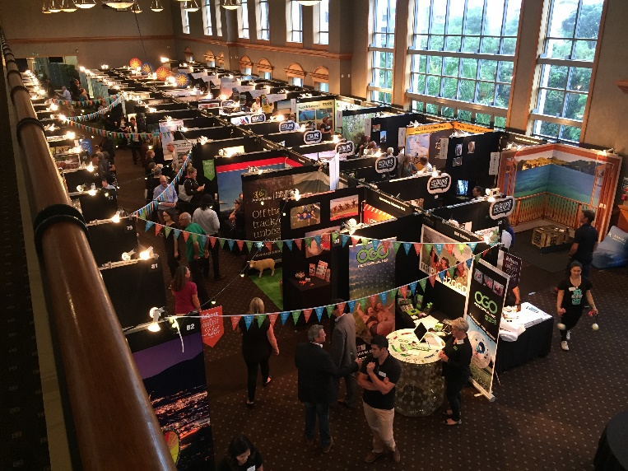 | eXplore  Trade Show 2019  15th April - Set Up, 16th April - Show  Hamilton & Waikato | Rotorua | Lake Taupo  Ruapehu | The Coromandel | Bay of Plenty  Tairawhiti-Gisborne | Hawke’s Bay

Exhibitor Prospectus 2019

The Event
This is a one-day tourism trade show to be held in Auckland in April 2019 and will be the 8th annual event for the eXplore Central North Island (ECNI) group. Last year saw over 220 NZ trade buyers registered to attend to visit 97+ operators and 8 RTO’s from throughout the Central North Island.

The Audience
As previous, the event is targeted at the main travel partners – Inbound Operators, Wholesale travel companies, as well as Hotel Concierges, frontline selling staff, and travel industry media. You can expect over 200 buyers to attend the event during the course of the day ranging from the Product decision makers at Travel Inbound Operators and Wholesale Companies through to i-SITE frontline staff, the selling staff at retail travel agencies and inbound/wholesale companies, as well as Tourism NZ staff from the trade and media teams.
There is no better opportunity to capture so many quality NZ travel trade buyers and influencers
in one place, in one day, with a targeted, receptive audience!

eXplore Show 2019
Venue: Eden Park – North Level 5 Lounge, Auckland
Operator Pack In: Monday 15th April 3-5pm
Operator Function: Monday 15th April 5.15-7.30pm
Show Time: Tuesday 16th April 9am-3pm (Exhibitors 8.am Pl for briefing)
Operator Pack Out: Tuesday 16th April 2019 3pm-5pm
Watch the Video from last years event.

Exhibitor Criteria
1) You must be Trade Ready – that is - be prepared to discuss commissions and rates with inbound and wholesale travel companies. If you need some more information on what it means to be Trade Ready or some help getting there, please contact your local Regional Tourism Organisation, who would be only too happy to help. See RTO Contact List at the end of the document.
Tip: check out www.tourismexportcouncil.org.nz – Planning for Export Success

2) You will need to allow two days out of your schedule for this event for the Pack-in, Operator Networking Function, Show day, and Pack-out.
NOTE: Your business contact details including email address will be given to the buyers in the Event Programme and emailed to them following the event.

Details of the Event Day - Tuesday April 16th

For exhibitors the event will begin 8am with an exhibitors briefing, and for buyers doors open officially at 9:00am (although there are always early arrivals). The event finishes at 3pm. As buyers arrive they will be met by an ECNI representative to check in and a business card will be collected from each buyer so that after the event you are given a full database list of who attended to enable you to commence your follow-up.
Each buyer will be offered a bag and an event programme which includes an exhibitor list, a layout of the venue, and a small profile on your business. As previous, the venue layout will ensure buyers have to pass all exhibitors.

Getting the Buyers There.

There will be buyers attending during the day from Inbound and Wholesale Travel companies, Tourism New Zealand, Tourism suppliers and Media. The eXplore Central North Island group will be marketing this event to buyers through a wide range of publications, direct invitations and mail outs as well as you assisting by emailing your databases of travel, corporate and event contacts. The marketing for this show will include:
- Updates in Regional Tourism Organisations newsletters to Trade
- Advertising in industry publications – Inside Tourism and Meeting News
- Inclusion in industry calendars of the event where possible
- Emailed invitations to buyers in the greater Auckland region
- The combined travel trade and MICE Databases of eCNI and our 8 RTO’s
- Phone follow ups to those still to register
- RTO’s at the IBO event the week prior to hand out information re the event.
- Email reminder the day before the event to all RSVPs
NEW! In 2019 we will look to support some key Australian Buyers to attend by invitation only and have them join us at the Operator function on the Monday night.

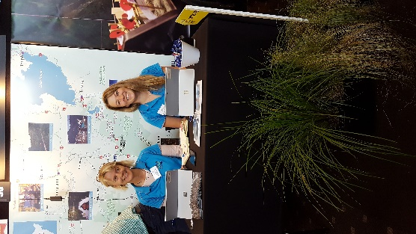 | 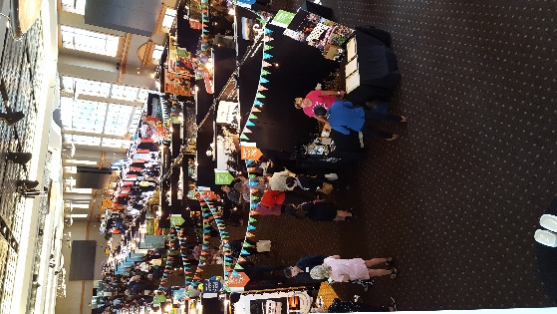 | 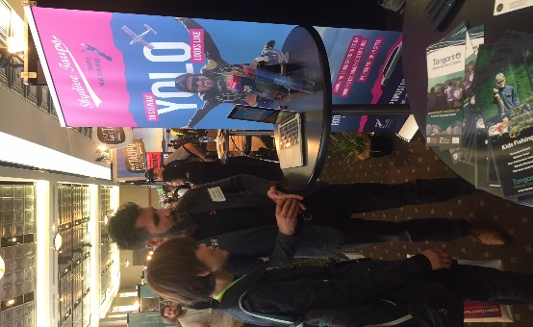

Exhibitor Stands

- It is recommended that you have two people on your stand to enable you to get the most out of the show, as well as to ensure your stand has someone present at all times. However, more than 2 is a real squeeze! Additional Show Day Delegates will incur a $50+gst pp fee.

- You need to have a visually appealing stand that is relevant to your product and the buyers to come and see you, you will also want to work hard to engage them as they come round. Competitions, prizes, and ‘talking point’ items work well to achieve this. In most regions your RTO will work with you to present a united front around signage and furniture – they will be in contact with you directly on that, and it is possible there may be an additional theming fee payable to the RTO for your region.

- Serving of Food/Beverages – If you wish to serve food or beverages including alcohol on your stand this is not always possible due to the restrictions of Health and Safety at the venue, please contact us on info@explorecentralnorthislandnz.com prior to the event. We need to make a request with the venue well in advance to see if it can be accommodated.

- Please be advised - due to Health and Safety regulations given this is a ‘Work Site’, children under 12 will not be permitted entry during Setup or Packdown.

What Is Provided On Your Stand?

A stand will be set up 1.8m x 1.8m and 2.3m high (same size as TRENZ) with black Velcro receptive walls. Each stand includes minimum:
- 1 x small trestle table (725mm x 1200mm x 600mm), up to 3 x stacker chairs**
- 1 x power connection, 2 x spotlights
- 1 x Company name sign (as per your eXplore Show registration)
- 1 x Table cloth (if required)
- Name tags for your delegates (we will be in touch closer to the time to get your delegate details)
- A list of registered suppliers and buyers emailed prior to the event and full database following.
**Please note to upgrade furniture please arrange directly with Peek Exhibition at your cost.

What To Bring For Your Stand

- Marketing collateral for each visitor (brochures, information sheets etc)
- Ample supply of business cards
- Company signage/branding
- An extension cord, black insulation tape, Velcro dots or strips

New! This Year – HD Video Wall

We have contracted use of the giant HD Video walls in the venue and are available for you to visually showcase your business with a slide show or video on the big screen. You will get:
- 30 seconds screen time on one video wall
- Your video / presentation screens on rotation every 30 minutes
- Minimum of 10 plays at the eXplore Show
- Cost: $60+gst.
If you have an existing video or slide show that is longer than 30 seconds, or wish to be profiled on more than one screen (there are four in the room), you can purchase multiple 30 sec slots. Content must be supplied to ECNI in March 2019.

Event Cost and Cancellation

The cost of the event is $850 + GST.
You will be invoiced BY YOUR RTO in February for 20th March Payment, plus any regional themeing costs they have outlined to you as a confirmed exhibitor.
Cancellation by email prior to invoicing will not incur any fee. Cancellation March 20th – April 2nd will incur a 50% cancellation fee of $425+gst. Cancellation 3rd - 15th April will incur the full cost of exhibiting.

What Else Is Included In The Cost?

- Morning tea and lunch with all day Barista coffee and tea, on show day for up to 2 delegates.
- Design, Printing and distribution cost of invitations, event promotion and programmes
- Operator function on the evening of April the 15th, food and a beverage token will be supplied.
- Full buyer database post event of attendees.

What Is Not Included In The Cost?

- Your transportation to Auckland
- Your accommodation in Auckland for the night before and possibly the night after the show
- Any meals outside of the show itself
- Your booth display and collateral

How Do You Register?

Please complete the online form by clicking on the Registration link below.
Exhibitor Registrations close 31 January 2019.

Any Questions?

Contact Vanessa Payne at eXplore Central North Island, Ph 021 1653 547,
or email: info@explorecentralnorthislandnz.com

Or – Your local Regional Tourism Organisation
RTO Regional Contacts
The Coromandel - Lynette Dey  lynette@thecoromandel.com | Hamilton & Waikato Tourism – Katrina Soepnel  katrina@hamiltonwaikato.com
Tourism Bay of Plenty - Denise Siviter  denise@bayofplentynz.com | Destination Rotorua – Patrick Dault  patrick@rotoruanz.com
Tairāwhiti-Gisborne – Mel Ma'afu Sinoti  mel@gisbornenz.com | Destination Great Lake Taupo - Karen Rainbow  karen@lovetaupo.com
Hawke’s Bay Tourism – Kerryn Ralston  kerrynr@hawkesbaytourism.co.nz | Visit Ruapehu – Alex Pearce  Alex@visitruapehu.com

